- This example will attempt to demonstrate how to apply sets to quality control charts generated by the STATISTICA Quality Control Charts module for datasets having a Set-indicator variable.

Data Description

Open the 4 Sets.sta datafile (this file is not provided with the installed version of STATISTICA, so you may need to ask someone for this file…). It should look like this:

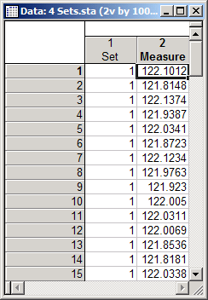

This file contains 2 variables and 100 cases. The first variable, Set, is an indicator variable designating to which set the User believes each measurement belongs. We suppose that there are 4 different sets in this data. The second variable, Measure, contains the actual quality measurements of interest.

Analysis

With this file as the active spreadsheet in STATISTICA, select Statistics | Industrial Statistics & Six Sigma | Quality Control Charts. On the Quick tab of the Quality Control Charts start-up dialog, select the Individuals & moving range option and click OK.

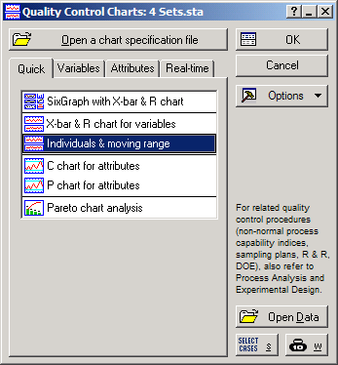

On the Defining Variables for X and Moving Range Chart dialog, click the Variables button and select Measure as the Measurements: variable and click OK.

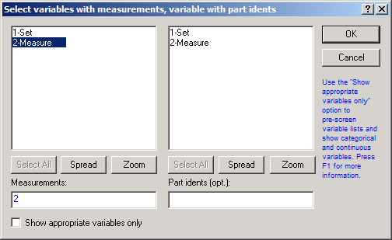

The Defining Variables for X and Moving Range Chart dialog should now look like this:

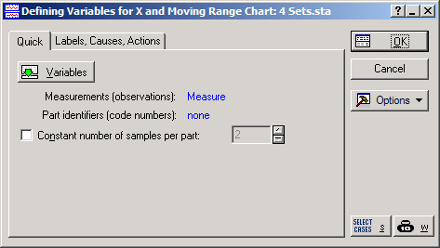

If it does, click OK to run the analysis.

The default quality control chart will automatically be displayed. Notice that a single set of control limits does seem inappropriate for this data.

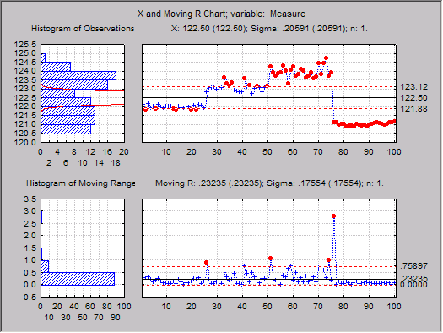

Now we will apply different control limits to the data according to the groups indicated in the Set variable. To do so, first bring-up the Results dialog by clicking the X/MR button on the Analysis bar in the lower left-hand portion of the application window or by pressing <CTRL>+<R> on your keyboard.
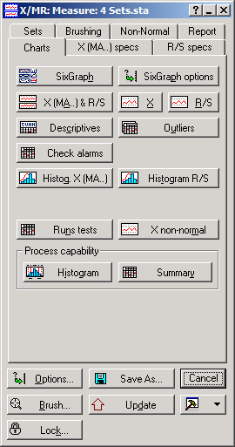

To specify the sets for the control chart, select the Sets tab and perform the following procedure for as many sets as you wish to apply (for this example we will perform the procedure 4 times):

- Enter the name of the set into the Label: field (e.g., Set 1).
- Select the Compute from option.
- Select the Samples with codes option near the bottom of the tab.
- Select the set-indicator variable and click OK (for this example, choose Set).
- Input the code corresponding to set in the Code: field (e.g., 1).
- Select the Apply to option.
- Select the Samples with codes option.
- Select the set-indicator variable and click OK.
- Input the code corresponding to the set in the Code: field.
- Click the Create Set button to apply the settings.
- Repeat for the next set until all sets have been specified. (*Note that some of the steps may not be necessary for subsequent steps, since they will have been remembered from previous sets. Specifically, steps 3, 4, 7, & 8 may not be necessary for subsequent steps. All others are, however.)

For this example, once all 4 sets have been specified, the Sets tab should look like this:

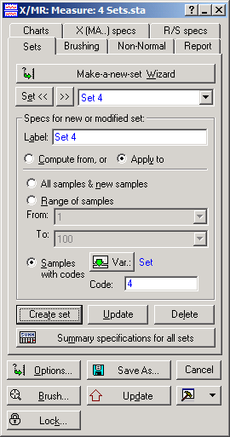

Once the sets have been properly specified, return to the Charts tab of the dialog and click the X (MA) & R/S button to obtain the new control chart. It should now look like this:

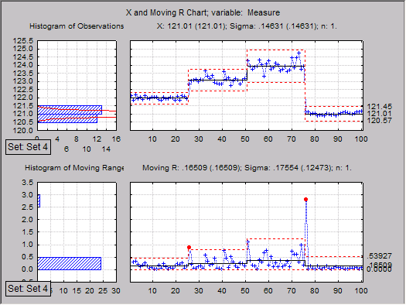

Note that each set now has its own control limits and centerline.

Other results with respect to the new sets are also available from the Results dialog, and you can create them if so desired by clicking their respective buttons.

